1. For event requests, list the event number, event date (*eventrequest.dateheld*), and count of the

event plans. Only include event requests in the result if the event request has more than one related event plan with a work date in December 2013.

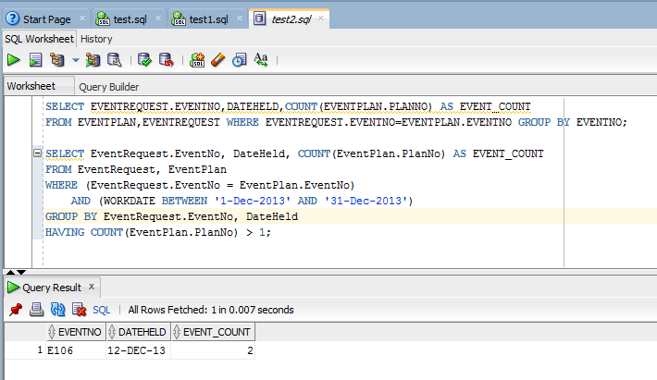

SELECT EventRequest.EventNo, DateHeld, COUNT(EventPlan.PlanNo) AS EVENT_COUNT

FROM EventRequest, EventPlan

WHERE (EventRequest.EventNo = EventPlan.EventNo)

AND (WORKDATE BETWEEN '1-Dec-2013' AND '31-Dec-2013')

GROUP BY EventRequest.EventNo, DateHeld

HAVING COUNT(EventPlan.PlanNo) > 1;